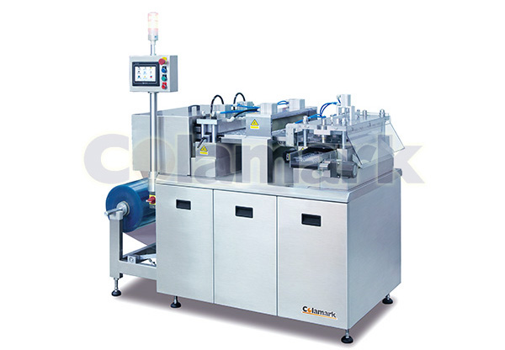
TFSeries Tray Former
- Work Process: Film infeed → Thermal softening → Molding & Cooling → Die-cutting → Collection (stand alone mode) or to Tray Inserter (inline mode)
- Compact and small foot-print.
- Servo driven film movement for fast and precise film positioning.
- PLC controlled operation.
- User friendly touch control panel HMI.
- Safety enclosure.
- Multiple trays per mold possible.
- Seamless connection to Colamark’s tray insertion machine.
Model： | TF
Name： | Series Tray Former
Capacity： | 20-40ppm
Weight： | 520kg
Electricity: | 380V 50Hz 2.5kW
Dimension(for reference)： | L)2,200×(W)1,738×(H)1,867 mm

